
A 10
SET NO : 1

Sreenidhi Institute of Science & Technology
(An Autonomous Institution)
Code No:101MA02

B. TECH. I – Year I – Semester Examinations, February, 2011 (Regular)
Mathematics for Bio-Technology-1 (BT)

Time: 3 Hours Max. Marks : 70

Note : No additional answer sheets will be provided.

Part-A (Objective Type)
Max.Marks:20

Answer all QUESTIONS.

1. Evaluate 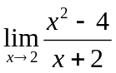
2. Find 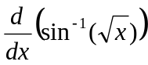
3. Find the equation of the tangent to the curve 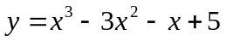 at (1,2).
4. If 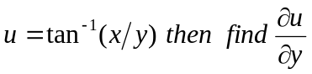.
5. Evaluate 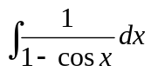
6. Evaluate 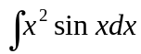
7. Evaluate 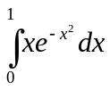
8. Form the differential equation by eliminating the arbitrary constants a, b from the equation y = a cos (nx + b)
9. Solve 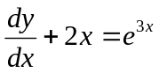
10. If f(x)=sinx, then find the area of the region under the curve from x = 0 to x = .

Part – B
Max. Marks: 50

ANSWER ANY FIVE QUESTIONS.
EACH QUESTION CARRIES 10 MARKS.

1. a. Evaluate 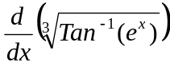 (5M)
b. Evaluate 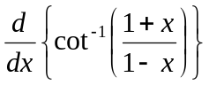 (5M)
2. a. Show that the function 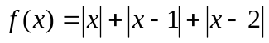is continuous at x = 0. (6M)
b. Evaluate 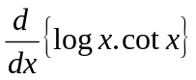 (4M)
3. Find the equations of tangent and normal at the point (a,a) on the curve 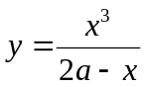.`
(10M)
4. a. If 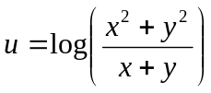then prove that 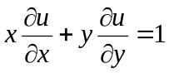. (5M)
b. If 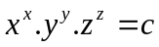 then find 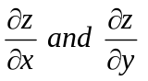 . (5M)
5. a. Evaluate 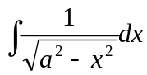 (4M)
b. Evaluate 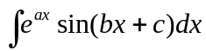 (6M)
6. a. Show that 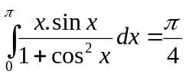. (5M)
b. Find the area bounded by the curve y = x and y = x² on [0,1]. (5M)
7. a. By eliminating A, B from the differential equation of which y = A e^{-2x} + Be^{5x} is a solution. (5M)
b. By eliminating A, B form the differential equation of which (x - A)² + (y - B)² = r² is a solution. (5M)
8. a. Solve 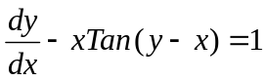 (5M)
b. Solve 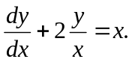 (5M)
- 0 - 0 -

